VStar Retrieval of Catalina Sky Survey Data

Catalina Sky Survey (CSS)
The primary mission of the Catalina Sky Survey (http://www.lpl.arizona.edu/css/index.html) is to identify potentially hazardous near-earth objects (NEOs). After realizing the additional potential use of the data, astronomers initiated the Catalina Real-Time Transient Survey (CRTS - http://crts.caltech.edu/index.html) to find “optical transients” including supernovae and cataclysmic variables. More detail about the history of CRTS can be found at http://uanews.org/story/catalina-sky-survey-spawns-catalina-real-time-transient-survey
Installation of Catalina Sky Survey file reader
On the VStar menu line select Tool -> Plug-in Manager…
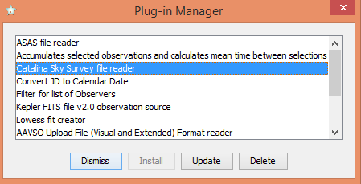
Select Catalina Sky Survey file reader. If it is not yet installed select the “Install” box. If it requires an update, the “Update” box will be active for selection as shown in this image. If the current version on your computer is up-to-date, neither Install nor Update will be active – just select “Dismiss”. Close and restart VStar. After restarting selecting File opens –
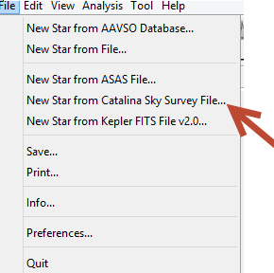
The “New Star from Catalina Sky Survey File…” is the option used to load a CRTS file.

Accessing CRTS Data
CRTS data can be retrieved at http://nesssi.cacr.caltech.edu/DataRelease/. As of May 10, 2014 all CSS data taken as of May 1, 2014 is accessible. Options are available to retrieve data by locations, object name and Catalina ID. The web page contains the retrieval links under “Data Services” at the top of the page or “Data Access” in the middle of the page –
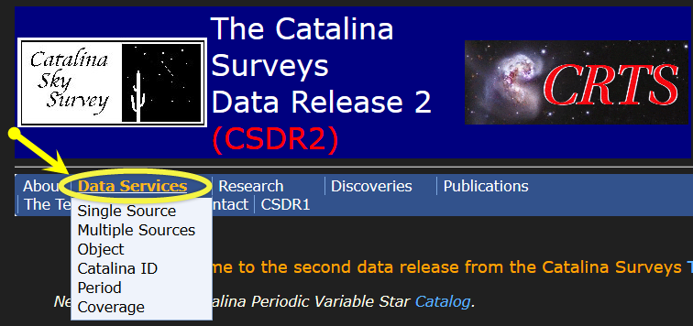
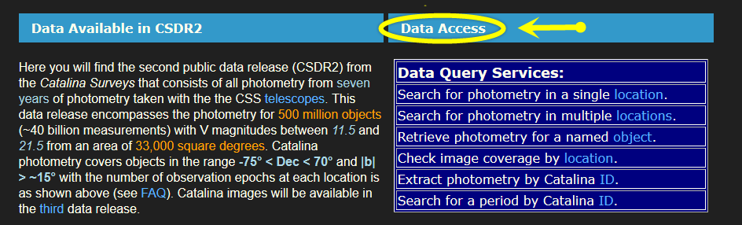
Using the “Retrieve photometry for a named object” as an example, brings up this window:
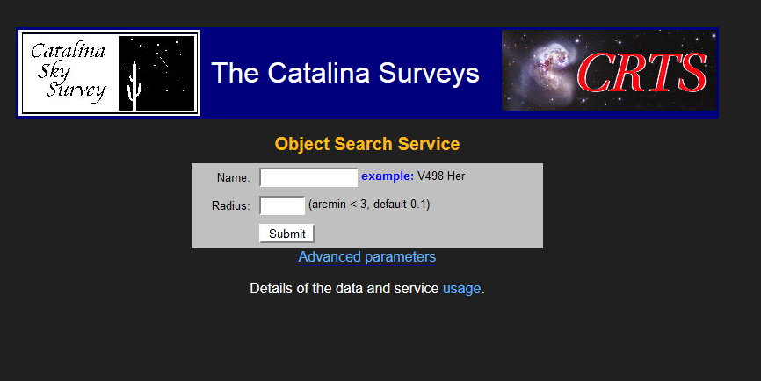

In addition to the object name, you enter the radius of the search area. (One note from experience – sometimes the 0.1 arcmin is too small to retrieve any data. Expand it – gradually – to find the data you need.)
When the Advanced parameters link is selected, there are a number of format options. The default is ASCII (CSV) but there's also VOTable, HTML and for each of these, a long and short format (the default is short). The VStar plug-in currently (June, 2014) handles only the "short format" CSV files:
MasterID Mag Magerr RA Dec MJD Blend
1140046004742,13.05,0.05,164.84942,39.73488,53712.41388,0
1140046004742,13.04,0.05,164.84938,39.73486,53712.42062,0

Additional Format Information:

You don’t need the following information to load CRTS data, but it is included here for you general knowledge. There are three Catalina surveys: CSS (Catalina Sky Survey), SSS (Siding Spring Survey) and MLS (Mount Lemmon Survey). The data from all three are often referred to with just the name “CSS Survey” or “CRTS Survey”

The csv file downloaded from the CRTS site contains all the available data together.
Each survey has a different MASTER ID (first parameter in each line.)

For example, for a recently discovered CV ASASSN-14bi there are three MASTER IDs:
1012087065473 = CSS_J163313.6-124533
2012225012820 = MLS_J163313.6-124533
3013121045940 = SSS_J163313.6-124534

MASTER IDs starting with 1 correspond to the Catalina Sky Survey MASTER IDs starting with 2 correspond to the Mount Lemmon Survey MASTER IDs starting with 3 correspond to the Siding Spring Survey.

In this example we enter GW Lib with a radius of 0.1 arcmin –
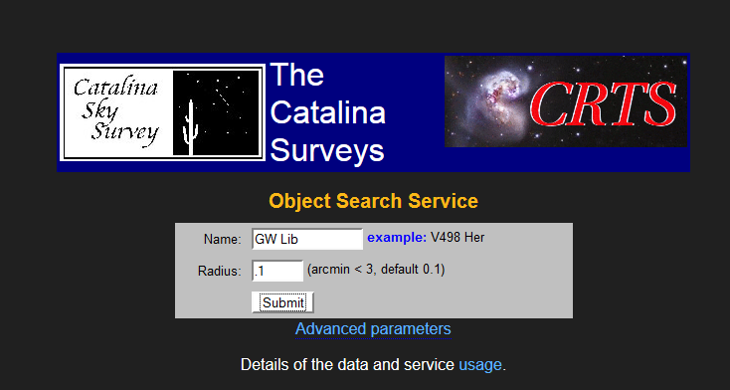
This results in the following:
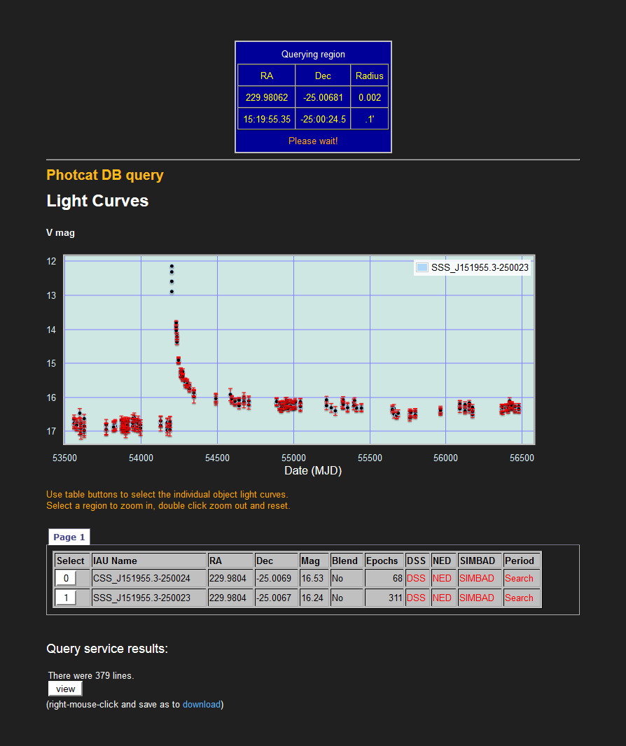

(Note the IAU name for the two data sets differ – CSS and SSS. This is because the Catalina Sky Survey (CSS), Mt. Lemmon Survey (MLS) and Siding Spring Survey (SSS) work together under the name of the first survey.)

Download the data to your computer by either selecting View (and copying/pasting the results), or right clicking download to save the file on your computer.

To load the data into VStar, select File -> New Star from Catalina Survey File (as explained above) and select the downloaded file. Data is now available for analysis:

